Community Infant Feeding Support

Consultation Document

kent.gov.uk/infantfeeding

Consultation closes 3 September 2017

Community Infant Feeding Support
2017 Public Consultation

The purpose of this consultation
We would like to hear your views on proposed changes to how Community Infant Feeding Support is provided in Kent.

Currently this support is provided by PS Breastfeeding CIC.

The proposed model is that from 1st Jan 2018 the Health Visiting Service (provided by Kent Community Health NHS Foundation Trust (KCHFT)) will deliver the support.

In designing the proposed model, Kent County Council has looked to ensure that families are still able to access the support that they need, at the same time as making best use of the existing professional skills and resources within the Health Visiting service.

This proposal would deliver a saving of £404,000 a year to KCC.

The consultation on this proposed model will run from 17th July 2017 to 3rd
September 2017.

Introduction
Kent County Council (KCC) commissions a range of services to help children and young people in Kent get the best start in life. These include:
- the School Public Health Service supporting 189,677 children between the ages of 5 and 18
- 85 Children’s Centres working with 65,500 children;
- the Health Visiting Service supporting families with 90,000 children under the age of 5; and

In addition, KCC Public Health also commissions the Community Infant Feeding Service.

The existing contract for the Community Infant Feeding Service has been extended until 31st December 2017. This has provided KCC with an opportunity to review how it can most efficiently deliver this service.

PS Breastfeeding Community Interest Company (CIC) is the current provider of the Community Infant Feeding Service.

The proposed model would transfer responsibility to the Health Visiting Service provided by KCHFT.

What is the current model?
Breastfeeding support, and information regarding formula feeding, is currently offered to all parents through the Health Visiting contacts, (Antenatal contact, New Birth visit and 6-8 week contact etc.), as well as within community based drop- in sessions (Child Health Clinics).

If Health Visitors (or other professionals) identify the need for extra support, families can be signposted to the Community Infant Feeding support provided by PS Breastfeeding CIC. The Community Infant Feeding Service is open access, so women can also refer themselves.

The diagram below shows a simplified picture of the support that is currently available to women; it does not describe the totality of the service, which includes staff and volunteer training, partnership work, social marketing and insight gathering.
The blue columns show what is currently provided by the Health Visiting Service and the pink columns show what is provided by PS Breastfeeding CIC. Although this diagram covers the first year of life only, the Health Visiting Service covers 0-5 years.

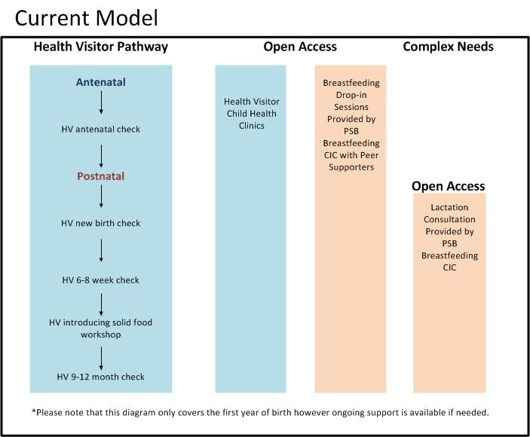
A summary of what is currently provided by PS Breastfeeding CIC is outlined below:

Advice to professionals and families

Provides information and advice, including training, where relevant, to the voluntary sector, NHS Trusts particularly health visitors and midwifery services and to children’s centres, primary care and local authorities.
Peer support training and supervision

Recruits, develops and supervises peer supporters. These are volunteers who have breastfed their own children and who have had accredited training to provide support with various aspects of breastfeeding such as positioning and attachment. They will also refer on to more qualified help if this is needed.

Lactation Consultant Clinics

Provides community based lactation clinics in all district and borough council areas. Lactation consultants are registered and qualified to provide specialist advice to mothers about infant feeding.

Project management, training and audit to support Baby Friendly Initiative

The Baby Friendly Initiative is the minimum standard for organisations offering advice and support with feeding. The programme is managed by UNICEF, on a self- financing model and they provide the accreditation. PS Breastfeeding CIC project manage this programme for Kent County Council Childrens Centres, to enable the authority to achieve full accreditation at Stage 3. Organisations achieve accreditation after evidencing infant feeding policy development, a satisfactory training prospectus, staff training and successful audits of staff competence and user satisfaction. https://www.unicef.org.uk/babyfriendly/

Website and resources

PS Breastfeeding CIC provides the Kent Baby Matters website which has a searchable website for clinics and drop-in sessions across Kent. It also publicises local and national evidence and resources.

Social marketing and insight

PS Breastfeeding CIC provides information to the public through social media.
It also sub-contracts to Activmob, who undertake interviews to provide insight into user and other stakeholder experience.

Co-ordination of baby friendly venues and campaigns

PS Breastfeeding CIC works closely with local councils and other organisations to promote a friendlier environment for women to feed their babies. They also co-ordinate public health campaigns on behalf of Kent County Council.

What is the proposed model?
The Health Visiting Service will continue to offer breastfeeding support, and information regarding formula feeding, to all parents through the Health Visiting contacts, as well as within community based clinic drop-in sessions.

However, if a need for extra support is identified, the proposal is that the support will be provided from within the Health Visiting Service. The diagram below shows a simplified picture of the support that will be available to women. It does not describe the totality of the work that is proposed. Although this diagram only covers the first year of life, the Health Visiting Service covers 0-5 years.
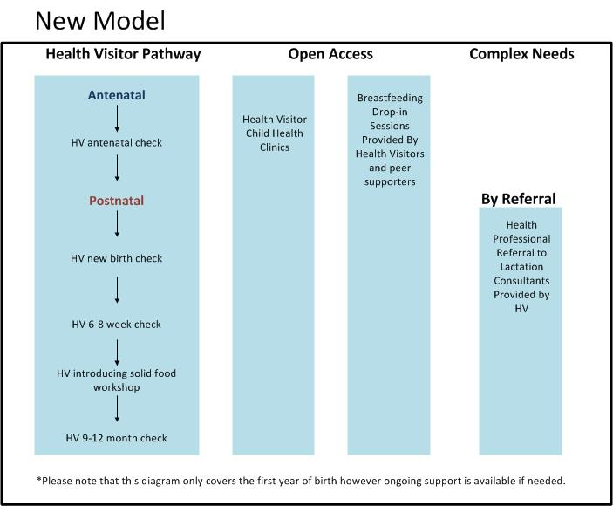

A summary of what is proposed is outlined below:

The universal health visiting contacts (Antenatal, New Birth visit, 6-8 week and 9-12 month contacts)

All women are contacted and offered advice and support and referred on to more specialist services if necessary. These are checks that cover all the needs of women and their families including feeding.

Drop-In Child Health Clinics

All parents are encouraged to attend Child Health Clinics to access further health visiting support. Each Child Health Clinic is run by members of the local health visiting team and offers advice and support on infant feeding as well as a range of topics related to babies and young children’s health and development e.g. Active Learner, Introducing Solid Food sessions etc. In addition there is a duty telephone line where feeding concerns can be raised, which is available Monday-Friday 9am-5pm.

New weekly Baby Hubs

Each support session will have a health visitor present alongside peer supporters. These are re-designed clinics with integrated breastfeeding support and health promotion activities. They will be provided in the following locations:

Ashford  - Waterside CC  - Willows CC  - Ray Allen CC | Sevenoaks, Swanley and Edenbridge  - Spring House (Town)  - Edenbridge CC  - Swanley CC
Canterbury and Coastal  - Little Hands CC  - Poppy CC  - Riverside CC | Shepway  - Caterpillars CC  - New Romney CC  - The Village CC
Dartford  - Brent CC  - Darenth CC  - Knockholt CC (or Oakfield) | Swale  - Seashells (Sheppey)  - St Mary’s CC (Faversham)  - Milton Court (Sittingbourne)
Dover Deal and Rural  - Buckland CC (Whitfield)  - Blossom CC (Deal)  - Triangle CC | Thanet  - Millmead CC  - Priory CC  - Callis CC
Gravesend  - Bright futures CC  - Next steps CC  - Little Pebbles CC | Tonbridge and Malling  - Snodland (The Hub)  - Woodlands CC (East Malling)  - The Hub Tonbridge (town)
Maidstone  - Salvation Army  - Meadows CC  - Headcorn CC (Rural) | Tunbridge Wells  - Little Forest (town)  - Cranbrook CC (rural)  - Paddock Wood (rural)

Current locations can be searched on the www.kentbabymatters.org website.

Training and supervision for volunteer Breast Feeding Peer Supporters

Training for the volunteer peer supporters will be delivered by the Health Visitor Service trained Baby Friendly Initiative (BFI) leads. KCHFT is currently seeking accreditation for their Peer Support Training Programme. In addition to training, the BFI leads will provide clinical supervision four times a year for two hours in a group setting for the Breast Feeding Peer Supporters.

The Health Visiting Service is aiming to maintain the current number of Peer Supporters.

Specialist support for breast feeding mothers

A local specialist breastfeeding clinic appointment will be available to any mother who is experiencing more complex breastfeeding issues, for example, latching difficulties, painful breastfeeding, and low milk production. They will also provide support for mothers whose babies are not gaining enough weight and other difficulties which may include issues such as mastitis and tongue tie. The specialist clinic appointments will be provided by the KCHFT Health Visiting Service Infant Feeding (IF) Leads alongside Lactation Consultants. Lactation Consultants will be outsourced during the interim period as existing staff are trained to become qualified specialists. Consultations will be on an appointment only basis, in response to a referral from a health professional which is based on clinical need.

In addition to the specialist clinic appointments, the Lactation Consultants and KCHFT IF Leads will be available to the health visiting teams, by phone. This will enable a fast response to more complex issues raised by breast feeding mothers at Breast Feeding drop-in sessions or Child Health Clinics.

The decision to explore changing to a referral system with fewer clinics was made after a review of attendance data. From the data it appears that the specialist clinic is the default service of choice, with fewer accessing peer support. From the last twelve months data available from the service, nearly 75% of women were seeing a lactation consultant compared with 25% accessing peer support. While it is appreciated that many families value the specialist support provided by the Lactation Consultants, we are not certain currently that all those accessing the specialist service actually have complex issues which require this level of support. It is likely that many could have their needs competently met by either a peer supporter or a health visitor. It is therefore proposed that initially there will be four Lactation Consultant led clinics a week across Kent. This will be a reduction in the current level of specialist support that is available in all twelve districts in Kent. There will be one specialist clinic in each of the East Kent, West Kent, North Kent and Kent Coastal areas every week. This service will be by appointment and will be flexible to offer home visits depending on how busy the clinics are. It is intended that if there are more referrals from health professionals from a particular location, the clinic can be flexible to move to the area of greatest need, to reduce unnecessary travel time. If there are not many referrals then home visits will be offered. These arrangements will be subject to review through performance management to ensure there is the right amount of specialist support based on clinical need. KCC is committed to ensuring that access to specialist support will be provided for all women and their babies who require this.

It is important for the Specialist service to be focussed on those families requiring most support and it is expected that the proposed health professional referral system will be an effective way to make the service more efficient and responsive to family needs. It is also important to highlight that the open access support, including peer support and health visitor advice, will remain available to all and will continue to capably address the majority of issues involved in infant feeding support.

Healthy Eating workshops (Introduction to Solids and Family Meals)

Part of the core role of the KCHFT Health Visiting Team is to advise all parents on up to date information related to introducing solids and moving onto healthy family meals.

Each district will offer a rolling parent programme which includes a Solids Workshop Session. These sessions provide parents with all the information they need to know about healthy eating and healthy start vitamins.

Communication campaigns including Baby Friendly venues

Information about services will be given at all antenatal and new birth visit contacts. A poster will be distributed to all health centres, child health clinics, children’s centres and KCHFT will ensure libraries and nurseries have the information. The information will be on the Health Visiting service public view website

Infant Feeding Advice to health and social care and others

Nationally Health Visiting Teams lead and deliver the Department of Health’s Healthy Child Programme for all children age 0-5years. Healthy eating is an integral part of the Healthy Child Programme. Public Health England (PHE) has identified breastfeeding as one of the six high impact areas for health visiting. PHE state that health visitors are ideally placed to provide both support to individual mothers and to lead implementation and delivery of evidence-based public health programmes. across a locality.

Project management, training and audit to support Baby Friendly Initiative

KCHFT is currently at Stage 1 on the way to achieving Baby Friendly Initiative status In addition, it is proposed that it will also provide project management and training for the Children’s Centre process from 1st January.

6-8 week breastfeeding data collection

The Health Visiting Service is responsible for collecting the 6-8 week data on breastfeeding. Once the national target of 95% recording of women’s feeding method is achieved, there will be a baseline for prevalence on which improvement can be measured.

For full details of the proposed KCHFT Infant Feeding Model please see their attached document.

What difference will it make to families who need the Service?

Families who need extra support will still have access to the services they need. They will all be provided by KCHFT, rather than being referred to a separate agency.
Families will get the help they need in a more joined up and integrated way.

The table below shows what is currently available, compared to what it is proposed will be available after 1st January 2018.

What is currently provided by PS Breastfeeding C.I.C. | Change that families will see from the Health Visiting Service
Advice to professionals and families | This will continue to be provided by the Health Visiting Service
Peer support training and supervision | It is proposed that there will be no reduction in the numbers of peer support volunteers. The Health Visiting Service is still gathering all the information and being advised by UNICEF about the accreditation process. The Health Visiting Service has experience in delivering the more intensive BFI training package, so accreditation is likely to happen quickly.
Lactation consultant clinics | There will be fewer clinics available and they will no longer be open access. These will be provided according to clinical need through a health professional referral. The Health Visiting Service and KCC will be monitoring this change closely to ensure that the clinical needs of mothers and babies continue to be met.
Project management, training and audit to support the Baby Friendly Initiative accreditation | The Health Visiting Service is providing this already for their own accreditation process and will also provide this for Children’s Centres.
Website and resources | KCHFT will provide details of open access and duty telephone line services on its website.
Social marketing and insight work | This is currently provided by Activmob, who have provided very useful information on the voice of service users and other stakeholders. This has informed and continues to inform service improvement. Should this need to be provided in the future KCC can add it to its communication plans.
Co-ordination of baby friendly venues and campaigns | KCHFT is already involved in this work and will continue to work with partners. KCC Public Health will also take more responsibility for promoting breastfeeding.
Advocacy and lobbying | Although this is not part of the PS Breastfeeding CIC contract with KCC, it has been a valuable part of the work that they have undertaken. This will change as KCHFT does not have the independence of a third sector organisation to do this work. However, seeking and acting on the views of service users is a requirement for NHS Trusts and forms part of the KCC performance monitoring process for all contracts. The Health Visiting Service is, in addition, a member of the Regional Infant Feeding Network which does have a role for service improvement and lobbying for change.

Why do we believe Health Visitors are the right people to deliver this Service?

In line with guidance on The Healthy Child Programme and the Health Visitor 6 High Impact areas, we believe that the support for breastfeeding should be part of the core role of all health visitors. This will increase the reach of nutrition advice to families in Kent through a holistic framework that includes all aspects of infant health and that links to early help and maternity services.

Since responsibility for the Health Visiting Service was transferred to KCC in 2015, the remit of Health Visitors has been reviewed to ensure a more co-ordinated range of support for families.

We believe that the Kent Community Health NHS Foundation Trust (KCHFT) Health Visiting Service (which comprise of highly trained community public health nurses, and Community Nursery Nurses) are fully capable and are best placed to deliver this service.

Other options considered

- Ending the provision of Community Infant Feeding Support
There is clear evidence that this support is needed by families in Kent, and therefore ending its provision is not an appropriate option.

- Extending the contract with PS Breastfeeding CIC
PS Breastfeeding CIC has delivered the Community Infant Feeding Support over recent years. 3,478 individual women accessed the Peer Support and Lactation Consultant groups during April 2016-March 2017. However we believe that the KCHFT Health Visiting Service can offer a high quality service which will reach all women (approximately 17,000 births per year) and is more integrated with other parts of the health sector. Extending the existing contract would also cost KCC Public Health £404,000 a year which is not an efficient use of public funds.

What are the benefits of this proposed model?

We expect that this proposal will:
- enable all families to access nutrition advice as part of a comprehensive infant health service that links to Children’s Centres and maternity services

- make best use of the existing professional skills and resources in the Health Visiting Service

- provide a more ‘joined-up’ experience for families looking for advice and support on the full range of infant feeding issues

- deliver a saving of £404,000 without compromising the quality and accessibility of the service.

Engagement and Research Activity

As part of developing a whole system pathway for infant feeding in Kent, a significant amount of insight work has been undertaken with a wide range of stakeholders including service users. Service users and providers have expressed very similar views. Here is a summary of issues that are relevant to community infant feeding services:
- Support needs to be timely
- Little information or guidance on breastfeeding is being provided before birth
- Services are not joined up
- Support services need to be local, and home visits should be available as mothers may sometimes struggle to get out e.g. if they had a difficult delivery
- There is insufficient information about the peer support team or services available
- Rapid referral to a lactation consultant should be available when needed.
- Family members have an important influence on feeding decisions: fathers should be involved and supported
- Some women perceive breastfeeding as embarrassing and/or not normal
- Women worry about whether the baby is getting enough milk

As part of the development of the Health Visiting model there have also been discussions with PS Breastfeeding CIC, Early Help and KCHFT.

As a result of these conversations, we believe that transferring responsibility for community infant feeding support to the Health Visiting Service will be a more efficient use of resources and will allow families to access a timely, holistic and joined up system of support.

Equality Impact
KCC Public Health has also developed an Equality Impact Assessment on the implications of the change, which may be viewed on-line at www.kent.gov.uk/infantfeeding
.
In summary, there are a number of groups that Children’s Centre data suggests are not being reached (2016/17 data is included as an appendix to the EIA.). These groups include adults and children with disabilities, teenage parents and lone parents. As part of this consultation we have included a specific question about the needs of particular groups and we fully intend to reach the people that the EIA has shown that we lack information about.

We would now like to hear your views before a final decision is taken.

Outlined in the following section are details of how to get involved in this consultation.

Have your say
How to get involved and find out more information:

Consultation responses will be used to improve the draft model and associated service specifications, helping to make sure that they are designed around the needs of Kent residents.

Whether you are a past, current or future user of these services, a carer or relative of a service user, a member of the public, an existing or potential provider of services, or another stakeholder we are keen to hear your views and experiences.

Please visit www.kent.gov.uk/infantfeeding to complete the online questionnaire and view supporting documents and the Equality Impact Assessment.

Alternatively, complete the paper questionnaire and hand it in to your local Children’s Centre.

If you have any questions or want to email your response, please contact PHconsultation@kent.gov.uk.

More information about KCC’s previous consultation activity around Health Visiting can be viewed online at www.kent.gov.uk/healthychildren.

If you need the questionnaire or any other documents in an alternative format, please email alternativeformats@kent.gov.uk or call 03000 421533 (text relay service number: 18001 03000 421553). This number goes to an answering machine, which is monitored during office hours.

Kent County Council values all feedback and views provided. By completing the short questionnaire you will be assisting us to ensure that these services meet the needs of Kent residents.

Public Health England. Early Years High Impact Area 3: Breastfeeding. https://www.gov.uk/government/uploads/system/uploads/attachment_data/file/563921/Early_years_high_i*mpact_area3_breastfeeding.pdf

